**Functionnal and technical description of ElecSyr, Electrical Syringe Pump**

**B8C2D1C4**

Contents

1. Historical 3

2. Documents 3

2.1. Generic documents 3

2.2. Specific documents 3

3. Abbréviations and définitions 4

3.1. Definitions 4

3.2. Abbréviations 4

4. Purpose 4

4.1. Context 4

5. global description 4

5.1. Technical features 5

5.2. Human Machine Interface 5

6. Models 7

7. Functional descrption 8

7.1. State flow 8

7.2. Initialisation 9

7.3. Surveillance alimentation 9

7.4. Etat d’attente 9

7.5. Distribution 9

7.6. Avance rapide 10

7.7. Retour rapide 10

# Historical

|  |  |  |  |
| --- | --- | --- | --- |
| **Name** | **Modifications** | **Version** | **Date** |
| Sébastien LAURENT | Creation | 0.1 | 27/06/2020 |
| Sébastien LAURENT | English translation | 0.2 | 11/08/2020 |
|  |  |  |  |
|  |  |  |  |

# Documents

## Generic documents

|  |  |  |  |
| --- | --- | --- | --- |
| **Subject** | **Document Name** | **Reference** | **Version** |
|  |  |  |  |
| Sécurité performances pompes perfusion | Exigences particulières pour la sécurité de base  et les performances essentielles des pompes et régulateurs  de perfusion | IEC 60601-2 24 |  |
| Sécurité & performance appareils médicaux | Exigences générales pour la sécurité de base et les performances essentielles des appareils électro-médicaux | IEC 60601-1 |  |
| CEM des appareils médicaux | Exigences générales pour la sécurité de base et les  performances essentielles – Norme collatérale: Perturbations  électromagnétiques – Exigences et essais | IEC 60601-1-2 |  |
|  |  |  |  |

## Specific documents

|  |  |  |  |  |
| --- | --- | --- | --- | --- |
| **Subject** | **Document Name** | **Reference** | **Version** | **Comments** |
|  |  |  |  |  |
| functional Test report | Rapport de test AGEPS |  |  | On demand only |
|  |  |  |  |  |

# Abbréviations and définitions

## Definitions

## Abbréviations

|  |  |  |
| --- | --- | --- |
| PSE | : | Electrical Syringe Pump (In french, Pousse Seringue Electrique) |
|  |  |  |

# Purpose

The purpose of this document is to describe functionality and technical points of the ElecSyr Electrical syringe pump.

## Context

Dans le contexte de la pandémie actuelle, le pousse seringue électrique, PSE, permet d’injecter des médicaments selon plusieurs modes.

En réanimation, les patients atteints du COVID 19 nécessitent l’utilisation de 5 à 7 PSE afin de pouvoir injecter les médicaments différents.

Notre étude porte sur un PSE basique, nommé ElecSyr, permettant de répondre à l’urgence.

Ce pousse-seringues, bien que conçu pendant le pic de la pandémie, peut répondre à d’autres besoins.

Dans notre étude, nous prenons en compte les modes de fonctionnement suivant

* Continu : injection en continu d’un produit
* Bolus : injection ponctuelle à débit plus élevé. Le mode Bolus est un complément au mode continu. C’est-à-dire, que l’injection de la drogue etant en mode continu le praticien peut venir soulager le patient en lui injectant une dose plus forte ponctuellement

In the context of the current pandemic, the electric syringe pump, PSE, allows the injection of drugs in several ways.

In intensive care, patients with COVID 19 require the use of 5 to 7 PSE in order to be able to inject needed drugs.

Our study focuses on a basic PSE, called ElecSyr, to respond to the emergency.

This syringe pump, although designed during the peak of the pandemic, can meet other needs.

In our study, we take into account the following modes of operation

* Continuous injection of a product
* Bolus: a higher-flow one-off injection. The Bolus mode is a complement to the continuous mode. That is, that the injection of the drug being in continuous mode the practitioner can come to relieve the patient by injecting a higher dose punctually

# global description

## Technical features

ElecSyr is composed as folowing :



Main features are :

|  |  |
| --- | --- |
| **Built-in features** | Values |
| **Flow** | Min: 1 ml/h and max 1200ml/h |
| Step-by-step setting | 0,1ml/h |
|  |  |
| **Power** |  |
| 220V - 60Hz |  |
| Internal backup battery | More than 1 hour autonomy (tbc) |
| **Mode** |  |
| Continuous | Fixed flow adjusted by user |
| Bolus | 500ml/h for speed (this value may be change in configuration mode)  Durin bolus, injected volume is shown on screen |
| **Alert** |  |
| End Course Av | LED alert - Sound - message |
| End Race 10% | LED alert - Sound - message |
| Detection Occlusion | LED alert - Sound - message |
| sector/battery | LED battery / LED Sector |
| device failure (internal check) | message - Sound |
| **Syringes** |  |
| Possible adjustments | InternalTable of 6: default BD platispak 50ml Luer Lock |
| **Fixation** |  |
| on set |  |
| onvertical colonn |  |

## Human Machine Interface

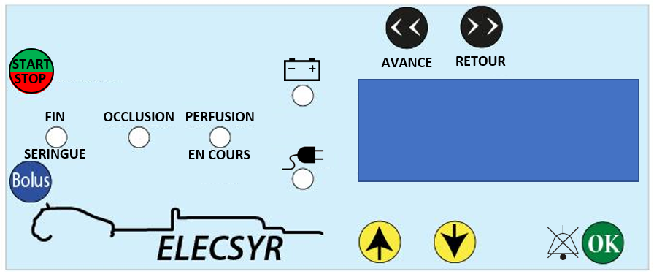

The HMI consists of:

* Start/stop button: used to start or stop the infusion
* Bolus button: used to launch the Bolus function
* Fast Forward button: used to move at high speed the trolley to meet the syringe
* Fast reward button: used to move in reverse speed the trolley.
* OK button: allows you to make and validate the settings (syringe choice, flow choice), to mute the sound of the alarms
* Button up: When settings it allows you to increment the flow values and choose the syringe
* Down button: When settings it allows you to decrement the flow values and choose the syringe
* Led End syringe: used to indicate 10% end of injection and end of injection
* Led Occlusion: It indicates an occlusion
* Led Perfusion in progress: green indicator indicating an infusion in progress
* Led Bat OK: Battery status indicator
* Led Sector OK: Industry Status Indicator
* A Buzzer makes sounds during different alarms
* An LCD with 2 lines – 16 characters allows you to see all the necessary information

# Models

Following different tests done and exchanges with medical people, different models were developed to take into account the constraints of hospitals (stackable, waterproof, syringe fixing points), functional constraints (spring or electronic overpressure sensor) and production tools (electronic board with through-hole technology or SMD, 3D printing and cutting).

Consequently, there are 10 possible versions of ElecSyr

|  |  |  |  |  |  |  |
| --- | --- | --- | --- | --- | --- | --- |
| **Assembly** | **Housing** | **mecanism** | **PCB** | **Software** | **Pressure sensor** | **comments** |
| 1 | C1 | 2 | Through hole | 1 | Spring | Checked by AGEPS |
| 2 | C1 | 2 | Through hole | 2 | Electronic (Tyco) | Checked by AGEPS |
| 3 | C1 | 2 | SMD | 1 | Spring | Equal to Assembly 1 |
| 4 | C1 | 2 | SMD | 2 | Electronic (Tyco) | Checked by AGEPS |
| 5 | C2 | 2 | Through hole | 1 | Spring | Equal to Assembly 1 |
| 6 | C2 | 2 | Through hole | 2 | Electronic (Tyco) | Equal to Assembly 2 |
| 7 | C2 | 2 | SMD | 1 | Spring | Equal to Assembly 1 |
| 8 | C2 | 2 | SMD | 2 | Electronic (Tyco) | Equal to Assembly 4 |
| 9 | C3 | 2 | SMD with reduced size | 1 | Spring | Digital version only |
| 10 | C3 | 2 | SMD with reduced size | 2 | Electronic (Tyco) | Digital version only |

Housing 1 : easy to stack

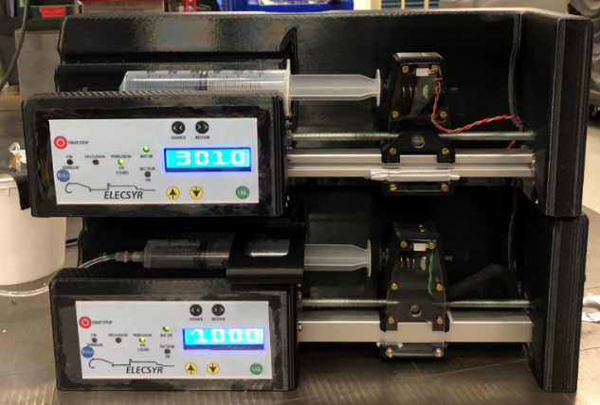

housing 2 : reduced height, stackable by small rods to put inside hole

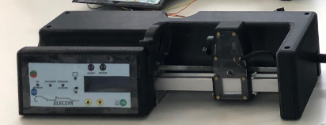

housing 3 : same as 2, with smaller length and width (-30mm)

Electronic board : through hole technology with Arduino board

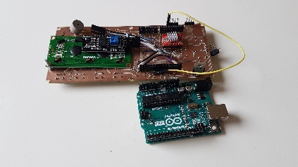 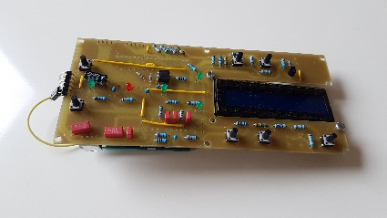

Electronic board: SMD technology (atmel IC is directly integrated on the board – no Arduino board)

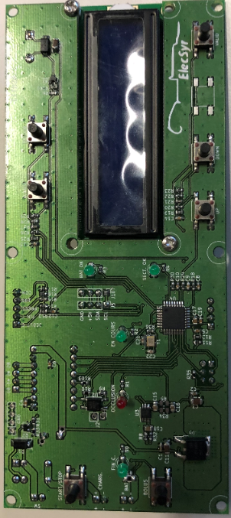

Spring pressure sensor

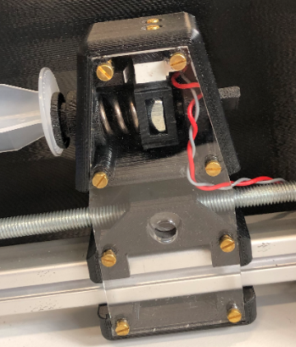

Electronic pressure sensor from TE Connectivty. The **FX29K0-100B-0025-**L was used instead of spring and mechanical detection. This systems allows to adjust with more accuracy pressure level It also helps in end of course detection and about syrnge positioning. With this sensor we are able to integrate an automatic fast positioning till syringe detection.

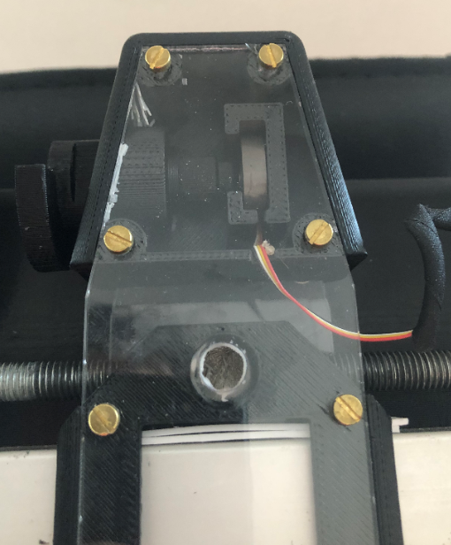

# Functional descrption

## State flow



## Initialisation

When power is set on , the device starts and makes internal checks. If ok, it initiates feed monitoring and puts itself in a state of waiting.

## Surveillance alimentation

The system checks states of main power supply and battery.

## Etat d’attente

In that mode, you can :

* Choice and validate the syringe by using Up & Down button and OK button

Syringe 1 corresponds to the plastipak luer lock 50ml BD

* Set the flow

Flow may be adjusted by UP and DOWN buttons and each number is validated by pressing OK button

## Distribution

Continuous:

Once the syringe and flow are validated, the Start/Stop button tap allows you to launch/stop the infusion.

At any time, if an infusion is in progress, the start/stop button stops the current infusion

Bolus :

A first push allows you to enter in Bolus function

A second continuous push launches the bolus function: the flow that appears on the screen corresponds to the additional quantity injected via the bolus function.

When the button is released, ElecSyr returns to its previous state (continuous infusion or waiting)

This mode is only available during continuous injection or waiting mode

## Avance rapide

By pushing it, you can move quickly the trolley in direct way

If Elecsyr is equipped with an electronic pressure sensor, this function is made automatically by a push.

If Elecsyr is equipped with mechanical pressure detection, a continue push is necessary to move the trolley.

## Retour rapide

By pushing it, you can move quickly the trolley in reverse way